ISRAEL: GOD’S PROPHETIC SIGNPOST
TO OUR ENDTIME GENERATION

ISRAEL’S WAR WITH ISLAMIC IRANIAN PROXIES & ENDTIME PROPHECY
Due to the unspeakably evil terrorist attack on Israeli civilians on October 07th, 2023 which included the demonic murder of innocent babies and children by the Iran backed terror group known as Hamas. And the subsequent declaration of War by Israel on this Islamic vehicle of hate and savagery; we decided to produce these messages and videos. No doubt you’ve already seen far too many images of the barbaric acts of this demonically driven death cult. Consequently, we sense the LORD wants us to focus on the prophetic implications of these events and what major endtime prophecies they’re leading towards. We also want to dispel any lies regarding who are the rightful occupants of this region known Biblically as the Promised Land. Yes, the primarily Arab Islamic descendants of Ishmael (the uncle of the Jewish people) controlled this region for many years since the Roman control of the Jews in Israel ended in the 7th century AD. After the Roman’s defeat of the second Jewish uprising in 135 AD many Jews fled or were dispersed from the land of Israel. However, a remnant of Jews has continually lived in the Holy Land even up until their Nation was reborn on May 14th, 1948. The name “Palestine” which is derived from the name Philistine was imposed upon the land of Israel by the Romans in 135 AD after the Jewish war for their independence was defeated. The Romans did this in order to humiliate the Jews and to demoralize any hope of their regaining control of the land that God had given them. After Roman control of the region faded with the demise of the Roman & Byzantine Empire in the 7th Century; various Islamic groups exercised control over the region. The Crusaders interrupted this Islamic dominance for a little over 100 years, but ultimately different Islamic groups maintained authority over the area for almost 1,200 years. This included the Ottoman Turks from 1516 AD to 1917 who allowed the land to deteriorate into a barren waste land as American writer Mark Twain described it during his visit to the Holy Land in 1869. This is what he said; “Of all the lands there are for dismal scenery, I think Palestine must be prince. The hills are barren, they are dull of color, they are unpicturesque in shape.” Sadly, under Islamic control the land suffered from neglect and became barren. However, after the British took control of the region in 1917 and pledged through the Balfour Declaration to establish a homeland for the Jews in Palestine things began to change. The Jews began to return to the Promised Land in ever increasing numbers despite fierce opposition from the surrounding Islamic and Arab nations. In 1948, the United Nations drew up a two state division of “Palestine” which Israel accepted and the nation of Israel was reborn, and simultaneously the militant Islamic Arabs rejected the offer and declared war. Israel by God’s grace and enablement soundly defeated the superior Arab forces from Egypt, Iraq, Lebanon, Syria, and Saudi Arabia. Ultimately, they set up an armistice agreement but the conflict has flared up on and off ever since. The truth is that the Islamic Arab populace living in the Promised Land and their leadership have been offered generous 2 State Solutions on five different occasions over the last century which they have openly rejected. Why? The problem is that radical Islamic groups like Hamas and Hezbollah and radicalized Islamic nations like Iran and Yemen refuse to acknowledge Israel’s right to exist. Part of their ideology and beliefs are the need for the genocidal destruction of Israel and the Jewish people. Consequently, they have no desire for a 2 State Solution. Their evil desire parallels that of Hitler and his Nazi regime which is “The Final Solution” … the extermination of the Jews. A genocidal belief that resulted in the wholesale slaughter of over six million Jews in WWII. This murderous “Nazi spirit” has changed its uniforms and location, but is alive and well operating through these radical Islamic groups and nations. With such murderous and uncivilized beliefs it is impossible for Israel to negotiate peace, no matter how much land they’re willing to give up. A popular Palestinian protest slogan illustrates this reality which declares; “From The River To The Sea Palestine Will Be Free.” The intent being to push the Jews into the sea as the Nazi’s pushed them into the gas chambers in Auschwitz. Therefore people who have been duped into supporting this genocidal destruction of Israel need to wake up to the evil of what they are supporting. And honestly look at the evidence of the savage atrocities of October 7th and put their support behind Israel or at least remain neutral. For Israel’s survival and protection of their civilian population; terrorist nations and groups like Hamas and Hezbollah must be dismantled or neutralized in order to prevent the genocidal destruction of their people. This includes the Islamic Iranian government “the head of the snake” which sponsors these terrorist proxies surrounding Israel and has aspirations of developing a nuclear arsenal. This radical Islamic government in Iran has sworn to destroy Israel and they will use nukes if given the chance. Therefore, they too must be stopped by Israel and the civilized world from ever developing such nuclear capability. The “Good News” for Israel is that through Bible prophecy we know that God is going to supernaturally rescue Israel from the unholy alliance and coming massive invasion of the Promised Land by Iran, Russia, Turkey and several other Islamic nations as revealed in Ezekiel 38 and 39. A little later we will be looking at how the stage is being set for the amazing fulfillment of this prophecy. First of all we want to confirm God’s promise to give Israel the land and His promise to bring them back into the land at the end of the age.

GOD’S PROMISE TO GIVE ISRAEL THE HOLY LAND FOREVER
Under Israeli care the Holy Land has been transformed from a waste land into one of the most agriculturally productive regions in the entire world. What we’re about to discover is that the Bible reveals that God promised the children of Israel that He would give them ownership and prosper them in the land known today as “Palestine” forever. And that He would bring them back to rule over it in the Endtimes. The Nation of Israel, the Jewish people and the City of Jerusalem are truly God’s major prophetic signposts to our Endtime generation. Some of the incredible last days prophetic fulfillments surrounding Israel that our generation has personally observed include:
- Israel being reestablished as a Nation on May 14th, 1948 (Mark 13:28-30)
- The Jewish people being regathered from among the nations back to the Promised land: In 1948 716,700 Jews lived in Israel only 6% of the world’s Jewish population. In 2023 7,145,000 Jews live in Israel a whopping 44% of the world’s Jewish population and growing (Ezekiel 37:21-23).
- Israel would retake control of Jerusalem which took place on June 7, 1967 after the 6 Day War.
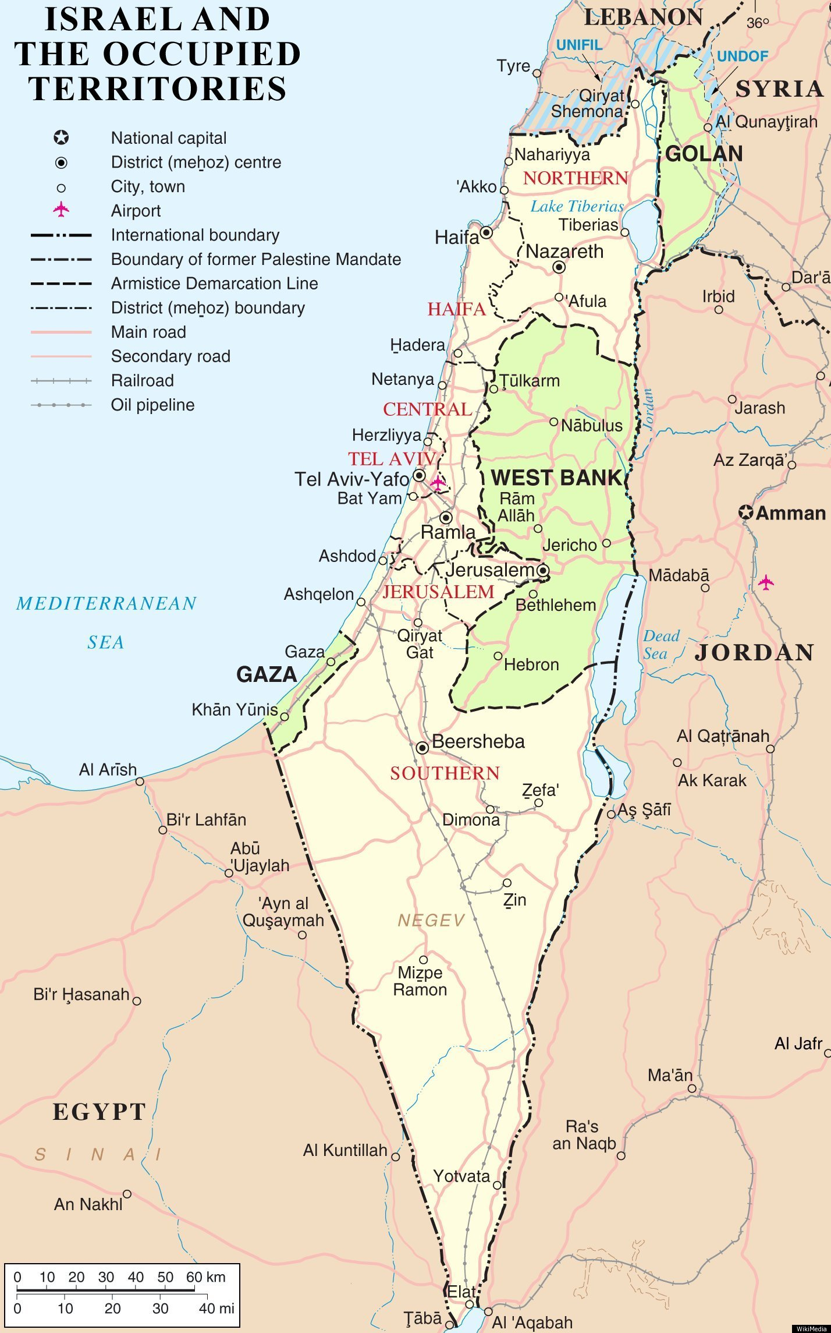
- Israel would blossom and bud and fill the face of the world with fruit (Isaiah 27:6). Today tiny Israel the size of New Jersey is one of the world’s leading producers of fresh citrus fruits and dates.
- Israel would become rich in wealth and resources and the invading nations especially Russia (Gog) would be desirous of getting control of such “spoil” (the main spoil is the oil and vast natural gas discoveries) (see Ezekiel 38:10-13). Israel today has amassed great wealth and is highly prosperous in industry and in research and development. Even more significant is the discovery of vast natural gas and oil deposits now being developed. These are the resources Russia covets and would like to control.
- Israel under the Temple Institutes leadership is boldly moving forward with plans to rebuild its 3rd Temple as Jesus, Daniel and other prophets predicted (Matthew 24:15; Daniel 12:11).
- The stage is now set for the Ezekiel chapter 38 and 39 invasion and war with all the major prophesied players including Russia, Iran and Turkey as well as other Islamic nations now uniting together in an unholy alliance against Israel. In Ezekiel 38 the ancient names revealed correspond to Israel’s Russian and Islamic enemies of today. Also the former Islamic enemies of Israel now at peace with her including Egypt, Jordan and Saudi Arabia (in process) are revealed in the text as not being involved in this invasion; amazing!
These awesome promises made over 2,000 years ago are all being fulfilled before our very eyes as Jesus and the prophets predicted. Now before we investigate the scriptural and prophetic merit of these incredible predictions, we want to confirm the Biblical promises to Israel regarding the Promised Land currently being referred to as Palestine.
ISRAEL, ABRAHAM’S COVENANT & THE PROMISED LAND
In this segment of our study we want to look at the scriptural promises to Abraham. In order to demonstrate beyond a shadow of doubt that Israel is the rightful occupant of the Holy Land even forever. We also want to discover the reality of irredeemable cultures and societies and how such cancerous demonically saturated cultures are surgically removed by God’s divine judgements. Also we want to discuss important life lessons from Abraham regarding the importance of acknowledging God in major decisions in our lives (Proverbs 3:5-6). And how not doing so can lead to horrible repercussions for our loved ones in the future. First of all, let’s examine God’s promises to Abraham regarding the Promised Land of Canaan and beyond!
Genesis 12:5-7 MEV ⁵ Abram took Sarai his wife, Lot his brother’s son, and all their possessions that they had accumulated, and the people that they had acquired in Harran, and they set out for the land of Canaan. They came to the land of Canaan. ⁶ Then Abram passed through the land to the place of Shechem, to the oak of Moreh. The Canaanites were in the land at that time. ⁷ The Lord appeared to Abram and said, “To your descendants I will give this land.” So he built an altar to the Lord, who had appeared to him.
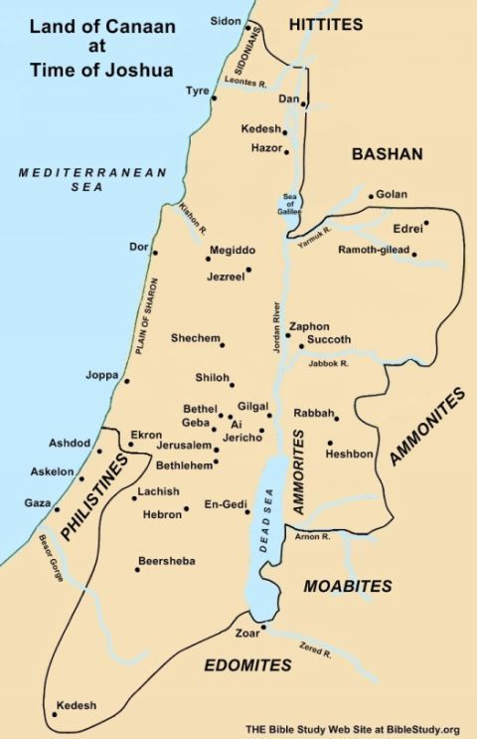
Genesis 15:13-18 MEV ¹³ Then He said to Abram, “Know for certain that your descendants will live as strangers in a land that is not theirs, and they will be enslaved and mistreated for four hundred years. ¹⁴ But I will judge the nation that they serve, and afterward they will come out with great possessions. ¹⁵ As for you, you will go to your fathers in peace and you will be buried at a good old age. ¹⁶ In the fourth generation, your descendants will return here, for the iniquity of the Amorites is not yet complete.” ¹⁷ When the sun went down and it was dark, a smoking fire pot with a flaming torch passed between these pieces. ¹⁸ On that same day the Lord made a covenant with Abram, saying, “To your descendants I have given this land, from the river of Egypt to the great Euphrates River—
Ezekiel 37:25-26 MEV ²⁵ They shall dwell in the land that I have given to Jacob My servant, in which your fathers lived. And they shall dwell in it, they and their sons and their son’s sons forever. And My servant David shall be their prince forever. ²⁶ Moreover I will make a covenant of peace with them. It shall be an everlasting covenant with them. And I will place them and multiply them and will set My sanctuary in their midst forevermore.
One thing the Palestinians and the whole world needs to understand is that the above scriptures as well as many others confirm that the Almighty, True and Loving God has given this disputed land to Israel for their possession. And that God’s will trumps or overrides any earthly authorities say in the matter, case closed. Another grim reality that needs to be understood in this historical scenario is how God deals with irredeemable cultures and societies. An irredeemable culture is a society that is so given over to demonic influence and evil that it cannot be changed or reformed. Consequently, it becomes like a social cancer that will continue to spread its evil influence unchecked unless it is destroyed. Three major examples of this in the Old Testament days is the society of Noah’s Day, Sodom and Gomorrah and the inhabitants of the land of Canaan the Amorites. In Genesis chapter 15 verse 16 it reveals that “the iniquity of Amorites was not yet complete.” In other words they were not a lost cause or irredeemable, but could still be changed.
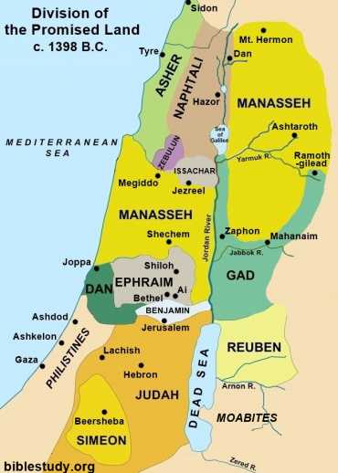
Sadly, they continued on their path of wickedness and after Israel came out of Egypt 400 years later, they had become irredeemable. The Lord then gave Israel the go ahead to destroy these cancerous cultures and to take possession of their lands as their own. You can see on the map of the land of Canaan how it corresponds to the map of Israel after Joshua had led them to possess the land as God ordained. One group in the promised land that Israel could not dispossess was the land of the Philistines and now we will discover why. Another factor not often considered in this historical context is why Gaza and the Philistines could not be destroyed by the children of Israel. To understand this we need to look at the Abrahamic covenant recorded in Genesis 21:22-24, 31-33 between Abraham and Abimelek the king of the Philistines and the Philistine nation.
Genesis 21:22-24, 31-33 MEV ²² Now it came to pass at that time that Abimelek and Phicol, the commander of his army, spoke to Abraham, saying, “God is with you in all that you do. ²³ Now therefore, swear to me by God that you will not deal deceitfully with me, or with my children, or with my descendants. Instead, according to the kindness that I have shown to you, you will show to me and to the land where you have lived.” ²⁴ Abraham said, “I will swear”… ³¹ Therefore he called that place Beersheba, because the two of them swore an oath there. ³² Thus they made a covenant at Beersheba. Then Abimelek rose with Phicol, the commander of his army, and they returned to the land of the Philistines. ³³ Abraham planted a tamarisk tree in Beersheba, and there he called on the name of the Lord, the Everlasting God.
Abraham covenanted before the Lord to respect the dwelling area of the Philistines of that day and that of their descendants after them. That is, that Abraham and his descendants after him would not confiscate or take control of the Philistines homeland which corresponds somewhat to today’s Gaza strip, but is longer (just beyond Ashod) and wider than today’s territory. Abraham’s son Isaac reaffirmed this covenant promise to the Philistines in Genesis 26:16-31. Consequently this covenant we believe is the explanation of why the Israelites were never able to drive the Philistines out of this area of the promised land. Every other heathen nation in the land God promised them, Israel was able to subjugate or destroy before them, but not the Philistines.
The reason for this seems to directly correlate to this covenant that was sworn before God between Abraham, Isaac and the Philistines and the God of the Bible is a covenant honouring God. Are there descendants of the Philistines today among the Palestinians who occupy Gaza? We believe this is a very remote possibility based on what Isaiah prophesied in Isaiah 14:28-31 MEV ²⁸ In the year that King Ahaz died was this oracle: ²⁹ Rejoice not, O Philistia, all of you, because the rod that struck you is broken; for out of the serpent’s root shall come forth a viper, and his fruit shall be a fiery flying serpent. ³⁰ The firstborn of the poor shall feed, and the needy shall lie down in safety: and I will kill your root with famine, and he shall slay your remnant. ³¹ Wail, O gate. Cry, O city. Melt away, O Philistia, all of you; for smoke shall come from the north, and there is no straggler in his ranks.
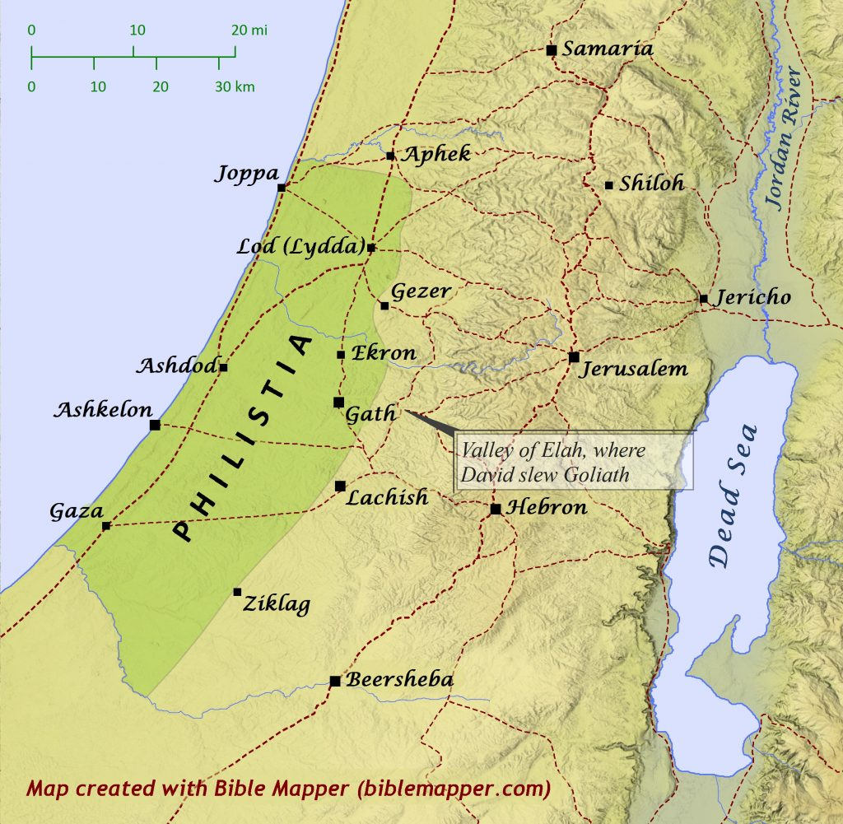
The Babylonian invasion of the land in 604 BC fulfilled this prophecy and likely wiped out the Philistines as predicted in Isaiah. In confirmation of their demise DNA research as recent as 2016 on an ancient Philistine graveyard in Ashkelon has revealed no correlation to modern day Palestinians living in Gaza. Abraham made two very costly decisions without consulting the Lord that we can all learn from. The first being, having a child with Hagar the Egyptian, his wife’s servant and the second was his covenant with Abimelek king of the Philistines. In proverbs chapter 3 verses 5 and 6, it instructs us to acknowledge the Lord in all our ways and He will direct our path. If we make important decisions without consulting the Lord it can have far reaching consequences that affects not only us, but also our descendants after us. Abraham’s decisions created Ishmael and the Arab nations that have plagued Israel to this day and the Philistines, who became a major destructive force against Israel for centuries. Despite Abraham’s ill-advised decisions the Lord faithfully fulfilled His promises in leading His people to possess their inheritance in the Promised Land.
Joshua 21:43-45 MEV ⁴³ The Lord gave Israel all the land that He swore to give to their fathers. They took possession of it and lived in it. ⁴⁴ The Lord gave them rest all around, according to all that He swore to their fathers. Not a man among their enemies stood before them, and the Lord delivered all their enemies into their hands. ⁴⁵ Not a single word of all the good things that the Lord had spoken to the children of Israel failed. They all came to pass.
From God’s Word we’ve established that the land of Israel was historically promised to Abraham and the children of Israel, and that it was successfully taken over by Israel under Joshua through God’s divine providence and power. Consequently, Israel occupied the land for almost 14 centuries up until the time of their dispersion under the Roman Empire in the 2nd century AD. Although they occupied the land for most of these 14 centuries, they did not always exercise jurisdiction over it due to major empires dominating the region. Which included the Babylonians, the Persians, the Greeks and the Romans. However the Jews occupied the territory under these empires oversight and have continually had a remnant of people living in the land up until the rebirth of Israel in 1948.
ISRAEL & THE PROMISE OF RESTORATION TO THE HOLY LAND IN ENDTIMES
Now we want to look at God’s prophetic promises to restore Israel to its Promised Land in the Endtimes just before Jesus’ triumphant return starting with Amos chapter 9.
Amos 9:14-15 MEV ¹⁴ I will restore the fortunes of My people Israel; they will rebuild the ruined cities and inhabit them; they will plant vineyards and drink their wine; they will make gardens and eat their fruit. ¹⁵ I will plant them upon their land, and no more will they be uprooted out of their land which I have given them. The Lord your God has spoken.
Ezekiel 37:21,25-27 MEV ²¹ Say to them, Thus says the Lord God: I will take the sons of Israel from among the nations where they have gone and will gather them on every side and bring them into their own land … ²⁵ They shall dwell in the land that I have given to Jacob My servant, in which your fathers lived. And they shall dwell in it, they and their sons and their son’s sons forever. And My servant David shall be their prince forever. ²⁶ Moreover I will make a covenant of peace with them. It shall be an everlasting covenant with them. And I will place them and multiply them and will set My sanctuary in their midst forevermore. ²⁷ My tabernacle also shall be with them. Indeed, I will be their God and they shall be My people.
Today, Israel and Jerusalem are God’s miracle testimony of His sovereign authority and power to restore a nation and fulfill His promises as the true and living God? Israel is a major prophetic signpost to our Endtime generation. Jesus and the prophets clearly declared that the land of Israel would be restored to the Jewish people (May 14th, 1948) and Jerusalem would be restored as their capital (June 7, 1967 after the 6 Day War) in the last days before His return. And that God would regather them from many nations and reestablish them in the promised land. Also that the generation that would see this happen would not pass away until all be fulfilled including Jesus’ return (Mark 13:24-31).
In Matthew 24 it is recorded that Jesus’ disciples asked Him what would be signs of His coming and the end of the age? Some of the key signs Jesus prophesied were very specific details regarding Israel’s restoration and their living in the Promised land and that the 3rd Temple would be rebuilt in Jerusalem under Israel’s control at the time of His return.
Matthew 24:15-21 MEV ¹⁵ “So when you see the ‘abomination of desolation,’^{[a]} spoken of by Daniel the prophet, standing in the holy place (let the reader understand), ¹⁶ then let those who are in Judea flee to the mountains. ¹⁷ Let him who is on the housetop not go down to take anything out of his house. ¹⁸ Let him who is in the field not return to take his clothes. ¹⁹ Woe to those who are with child and to those who nurse in those days! ²⁰ Pray that your escape will not be in the winter or on the Sabbath. ²¹ For then will be great tribulation, such as has not happened since the beginning of the world until now, no, nor ever shall be.
This prophecy Jesus is referring to in Matthew 24 is recorded in Daniel 9:24-27.
THE MOST AMAZINGLY ACCURATE PROPHECY OF ALL TIME
Daniel 9:24-27 KJVER ²⁴ Seventy weeks are determined upon your people and upon your holy city, to finish the transgression, and to make an end of sins, and to make reconciliation for iniquity, and to bring in everlasting righteousness, and to seal up the vision and prophecy, and to anoint the most Holy. ²⁵ Know therefore and understand, that from the going forth of the commandment to restore and to build Jerusalem to the Messiah the Prince shall be seven weeks, sixty two weeks, the street shall be built again, and the wall, even in troublous times. ²⁶ And after sixty two weeks shall Messiah be cut off, but not for himself: and the people of the prince that shall come shall destroy the city and the sanctuary; and the end thereof shall be with a flood, and unto the end of the war desolations are determined. ²⁷ And he shall confirm the covenant with many for one week: and in the midst of the week he shall cause the sacrifice and the oblation to cease, and for the overspreading of abominations he shall make it desolate, even until the consummation, and that determined shall be poured upon the desolate.
The Daniel 9 passage also reveals that the Messiah would be revealed and killed before the 2nd Temple is destroyed by the Romans. And that the Prince who shall come (i.e. the Antichrist) will set up the final or 70th week of Daniel’s prophecy through a 7 year Treaty as leader of the European Union (i.e. the Revised Roman Empire). It is very possible that this treaty or covenant may be negotiated as a result of the Ezekiel 38&39 war. Please make note that Jesus of “Nazareth fulfilled the prophecy of “Messiah the Prince” being revealed exactly 69 weeks, 483 years (69x7) after the command to restore and build Jerusalem on March 14, 445 BC. This took place at Jesus’ triumphal entry into Jerusalem on April 16th, 32 AD when He is acknowledged by the people as being their Messiah. Incredibly predicted some 700 years earlier. This thoroughly amazing prophecy is chronicled in detail in Sir Robert Anderson’s book “The Coming Prince.” Along with this Daniel predicted that after Messiah was recognized 173,880 days later, then He would “be cut off” (killed), but not for Himself.” Jesus Christ of Nazareth was put to death 4 days after His triumphant recognition as Messiah by crucifixion for the sin of all mankind. Again amazingly just as Daniel predicted. Jesus of Nazareth fulfilled these prophecies before General Titus of Rome and his Roman Legions destroyed the Temple and the City of Jerusalem in 70 AD. Proving beyond any shadow of doubt that He is the Jewish Messiah and Saviour of the world (Hallelujah!). The final 70th week or 7 years of Daniel’s prophecy will complete this astounding series of prophecies at the end of this age. When Jesus returns at the end of this 70th week by “bringing in everlasting righteousness” and God’s divine order over planet earth and by being anointed “the most Holy” King of the Universe … forever (Amen!)
Daniel 12:11-12 MEV ¹¹ “From the time that the daily sacrifice shall be taken away and the abomination that makes desolate set up, there shall be one thousand two hundred and ninety days. ¹² Blessed is he who waits and comes to the one thousand three hundred and thirty-five days.
This abomination of desolation could very well be “the image of the beast” prophesied in Revelation chapter 13. It may be an AI robotic clone of the Antichrist that will determine judgment on those among the world’s population who are all being tracked online by computer surveillance and found not to have received the Beast’s allegiance implant. It may possibly issue execution warrants on all who will not surrender in worship and service to the Antichrist and receive “his Mark” implant.
Revelation 13:11-16 MEV ¹¹ Then I saw another beast rising out of the earth. He had two horns like a lamb and he spoke like a dragon. ¹² He exercises all the authority of the first beast in his presence and causes the earth and those who dwell on it to worship the first beast, whose deadly wound was healed. ¹³ He performs great signs, making fire come down from heaven on the earth in the sight of men. ¹⁴ He deceives those who dwell on the earth by the signs which he was granted to do in the presence of the beast, telling those who dwell on the earth to make an image to the beast who was wounded by a sword and lived. ¹⁵ He was allowed to give breath to the image of the beast, that the image of the beast should both speak and cause as many as would not worship the image of the beast to be killed. ¹⁶ He causes all, both small and great, both rich and poor, both free and slave, to receive a mark on their right hand or on their forehead,
Another amazing prophetic endtime sign that Isaiah revealed which was mentioned earlier relates to the transformation of the land. Isaiah predicted that Israel which had been desolate and God forsaken for almost 2,000 years would “blossom and bud” and become one of the most productive agricultural areas in all the world after the Jews were restored to the promised land.
Isaiah 27:6 KJVER ⁶ He shall cause them that come of Jacob to take root: Israel shall blossom and bud, and fill the face of the world with fruit.
ISRAEL’S REBIRTH THE KEY SIGN TO THE TIMING OF JESUS’ RETURN
In Matthew 24, Mark 13, and Luke 21 Jesus shares the endtime signs of His return. He then explains to His disciples about the parable of “the fig tree.” In scripture and in Jewish culture the “fig tree” is a symbol of Israel.
Mark 13:24-31 MEV ²⁴ “But in those days, after that distress, ‘the sun will be darkened, and the moon will not give her light; ²⁵ the stars of heaven will fall, and the powers that are in heaven will be shaken.’^{[a] 26} “Then they will see the Son of Man coming in clouds with great power and glory. ²⁷ Then He will send His angels and gather His elect from the four winds, from the farthest part of the earth to the farthest part of heaven. ²⁸ “Now learn a parable of the fig tree: When her branch is yet tender and puts outs leaves, you know that summer is near. ²⁹ So also, when you see these things come to pass, know that it is near, even at the doors. ³⁰ Truly I say to you, this generation will not pass away until all these things happen. ³¹ Heaven and earth will pass away, but My words will not pass away.
Jesus in this passage describes His Rapture rescue of His people. Then He gives the key sign of the timing of His return related to the blossoming of the “Fig Tree.” In this text Jesus uses “the Fig Tree”, the figurative and cultural image of Israel as the primary sign of the timing of His return. Essentially, He prophesies that the generation that sees Israel blossom and put forth leaves as the “Fig Tree” (i.e. is restored) will not die until all be fulfilled including His return. Once again, the LORD uses Israel as the key prophetic signpost to our generation that will see His return.
ISRAEL & THE LOOMING RUSSIAN & ISLAMIC INVASION OF EZEKIEL 38&39
We believe the current war in Israel with Hamas in the South and Hezbollah in the North is setting the stage for the great invasion of Israel by Russia, Iran and Turkey along with their other Islamic allies prophesied in Ezekiel chapter 38 & 39. We also believe this current war against Hamas and Hezbollah, will ultimately spread to the terror cells in the West Bank and Syria. In order to neutralize all ongoing daily threats to the civilian population in Israel. This will ultimately bring the peaceful scenario portrayed in Ezekiel 38 verses 8,11 and 14 that will be present at the time of this mass invasion by Russian and Islamic forces. The ancient nations identified in Ezekiel 38:2-6 correspond to this modern unholy alliance of communist and Islamic nations currently aligning against Israel. Including Russia (Gog, the land of Magog); Iran plus potentially Iraq, Syria and Lebanon (Persian Empire – see map Pg. 11), (Persia); Turkey (Togarmah) North Sudan and Ethiopia (Ethiopia) and several other Islamic nations (see map). Another amazing thing about this prophetic passage is that it not only identifies the Islamic nations who will be involved in this invasion, but also those who will not be involved. This includes Egypt, Jordan who currently have peace accords with Israel and Saudia Arabia (Sheba & Dedan) which has a peace accord in process with Israel.
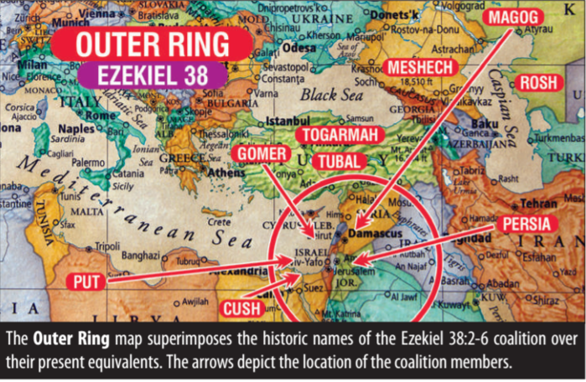
Ezekiel 38 38 And the word of the Lord came to me, saying, ² Son of man, set your face against Gog, the land of Magog, the chief prince of Meshech and Tubal, and prophesy against him, ³ And say, Thus says the Lord God; Behold, I am against you, O Gog, the chief prince of Meshech and Tubal: ⁴ And I will turn you back, and put hooks into your jaws, and I will bring you forth, and all your army, horses and horsemen, all of them clothed with all sorts of armour, even a great company with bucklers and shields, all of them handling swords: ⁵ Persia, Ethiopia, and Libya (Put) with them; all of them with shield and helmet: ⁶ Gomer, and all his bands; the house of Togarmah of the north quarters, and all his bands: and many people with you. ⁷ Be you prepared, and prepare for yourself, you, and all your company that are assembled unto you, and be you a guard to them. ⁸ After many days thou shalt be visited: in the latter years you shall come into the land that is brought back from the sword, and is gathered out of many people, against the mountains of Israel, which have been always waste: but it is brought forth out of the nations, and they shall dwell safely all of them. ⁹ You shall ascend and come like a storm, you shall be like a cloud to cover the land, you, and all your bands, and many people with you. ¹⁰ Thus says the Lord God; It shall also come to pass, that at the same time shall things come into your mind, and you shall think an evil thought: ¹¹ And you shall say, I will go up to the land of unwalled villages; I will go to them that are at rest, that dwell safely, all of them dwelling without walls, and having neither bars nor gates, ¹² To take a spoil, and to take a prey; to turn your hand upon the desolate places that are now inhabited, and upon the people that are gathered out of the nations, which have gotten cattle and goods, that dwell in the midst of the land. ¹³ Sheba, and Dedan, and the merchants of Tarshish, with all the young lions there, shall say to you, Art you come to take a spoil? Have you gathered your company to take a prey? to carry away silver and gold, to take away cattle and goods, to take a great spoil? ¹⁴ Therefore, son of man, prophesy and say unto Gog, Thus says the Lord God; In that day when my people of Israel dwells safely, shall you not know it? ¹⁵ And you shall come from your place out of the north parts, you, and many people with you, all of them riding upon horses, a great company, and a mighty army: ¹⁶ And you shall come up against my people of Israel, as a cloud to cover the land; it shall be in the latter days, and I will bring you against my land, that the heathen may know me, when I shall be sanctified in you, O Gog, before their eyes. ¹⁷ Thus says the Lord God; Are you he of whom I have spoken in old time by my servants the prophets of Israel, which prophesied in those days many years that I would bring you against them? ¹⁸ And it shall come to pass at the same time when Gog shall come against the land of Israel, says the Lord God, that my fury shall come up in my face. ¹⁹ For in my jealousy and in the fire of my wrath have I spoken, Surely in that day there shall be a great shaking in the land of Israel; ²⁰ So that the fishes of the sea, and the fowls of the heaven, and the beasts of the field, and all creeping things that creep upon the earth, and all the men that are upon the face of the earth, shall shake at my presence, and the mountains shall be thrown down, and the steep places shall fall, and every wall shall fall to the ground. ²¹ And I will call for a sword against him throughout all my mountains, says the Lord God: every man's sword shall be against his brother. ²² And I will plead against him with pestilence and with blood; and I will rain upon him, and upon his bands, and upon the many people that are with him, an overflowing rain, and great hailstones, fire, and brimstone. ²³ Thus will I magnify myself, and sanctify myself; and I will be known in the eyes of many nations, and they shall know that I am the Lord.
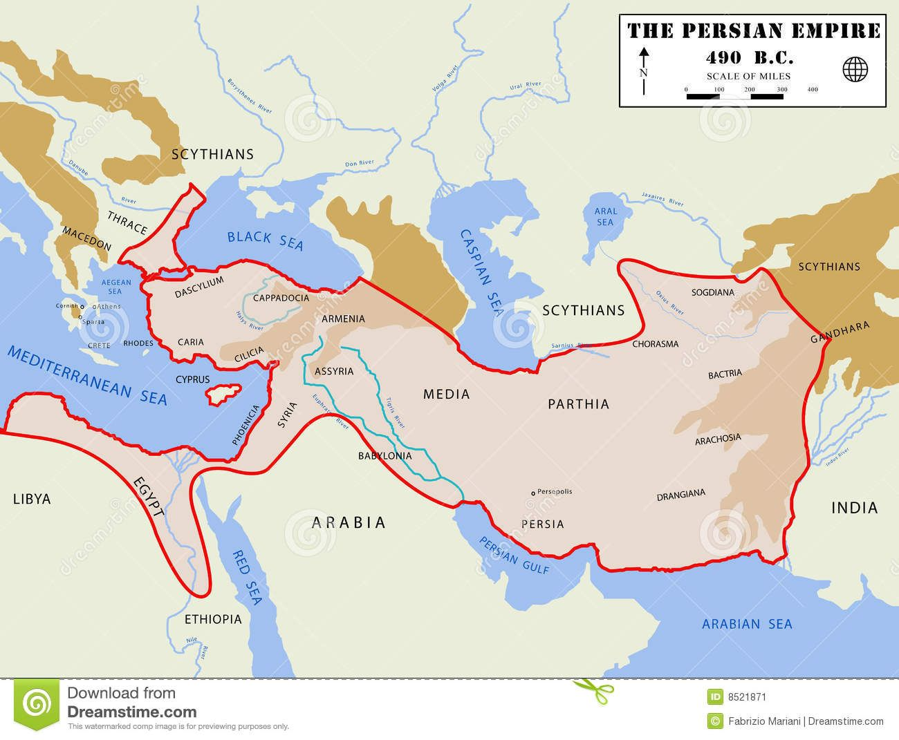
Ezekiel 39 Therefore, you son of man, prophesy against Gog, and say, Thus says the Lord God; Behold, I am against you, O Gog, the chief prince of Meshech and Tubal: ² And I will turn you back, and leave but the sixth part of you, and will cause you to come up from the north parts, and will bring you upon the mountains of Israel: ³ And I will smite your bow out of your left hand, and will cause your arrows to fall out of your right hand. ⁴ You shall fall upon the mountains of Israel, you, and all your bands, and the people that is with you: I will give you to the ravenous birds of every sort, and to the beasts of the field to be devoured. ⁵ You shall fall upon the open field: for I have spoken it, says the Lord God. ⁶ And I will send a fire on Magog, and among them that dwell carelessly in the isles: and they shall know that I am the Lord. ⁷ So will I make my holy name known in the midst of my people Israel; and I will not let them pollute my holy name any more: and the heathen shall know that I am the Lord, the Holy One in Israel. ⁸ Behold, it is come, and it is done, says the Lord God; this is the day whereof I have spoken. ⁹ And they that dwell in the cities of Israel shall go forth, and shall set on fire and burn the weapons, both the shields and the bucklers, the bows and the arrows, and the javelins, and the spears, and they shall burn them with fire seven years: ¹⁰ So that they shall take no wood out of the field, neither cut down any out of the forests; for they shall burn the weapons with fire: and they shall spoil those that spoiled them, and rob those that robbed them, says the Lord God. ¹¹ And it shall come to pass in that day, that I will give to Gog a place there of graves in Israel, the valley of the passengers on the east of the sea: and it shall stop the noses of the passengers: and there shall they bury Gog and all his multitude: and they shall call it The valley of Hamongog. ¹² And seven months shall the house of Israel be burying of them, that they may cleanse the land. ¹³ Yes, all the people of the land shall bury them; and it shall be to them a renown the day that I shall be glorified, says the Lord God. ¹⁴ And they shall sever out men of continual employment, passing through the land to bury with the passengers those that remain upon the face of the earth, to cleanse it: after the end of seven months shall they search. ¹⁵ And the passengers that pass through the land, when any sees a man's bone, then shall he set up a sign by it, until the buriers have buried it in the valley of Hamon Gog. ¹⁶ And also the name of the city shall be Hamonah. Thus shall they cleanse the land. ¹⁷ And, you son of man, thus says the Lord God; Speak to every feathered fowl, and to every beast of the field, Assemble yourselves, and come; gather yourselves on every side to my sacrifice that I do sacrifice for you, even a great sacrifice upon the mountains of Israel, that you may eat flesh, and drink blood. ¹⁸ You shall eat the flesh of the mighty, and drink the blood of the princes of the earth, of rams, of lambs, and of goats, of bullocks, all of them fatlings of Bashan. ¹⁹ And you shall eat fat until you be full, and drink blood until you be drunk, of my sacrifice which I have sacrificed for you. ²⁰ Thus you shall be filled at my table with horses and chariots, with mighty men, and with all men of war, says the Lord God. ²¹ And I will set my glory among the heathen, and all the heathen shall see my judgment that I have executed, and my hand that I have laid upon them. ²² So the house of Israel shall know that I am the Lord their God from that day and forward. ²³ And the heathen shall know that the house of Israel went into captivity for their iniquity: because they trespassed against me, therefore hid I my face from them, and gave them into the hand of their enemies: so fell they all by the sword. ²⁴ According to their uncleanness and according to their transgressions have I done to them, and hid my face from them. ²⁵ Therefore thus says the Lord God; Now will I bring again the captivity of Jacob, and have mercy upon the whole house of Israel, and will be jealous for my holy name; ²⁶ After that they have borne their shame, and all their trespasses whereby they have trespassed against me, when they dwelt safely in their land, and none made them afraid. ²⁷ When I have brought them again from the people, and gathered them out of their enemies' lands, and am sanctified in them in the sight of many nations; ²⁸ Then shall they know that I am the Lord their God, which caused them to be led into captivity among the heathen: but I have gathered them to their own land, and have left none of them anymore there. ²⁹ Neither will I hide my face any more from them: for I have poured out my spirit upon the house of Israel, says the Lord God.
This passage clearly reveals that this huge nefarious invasion will happen “in the latter years” or in the Endtimes (38:8 & 16). Also that it will be in a time after the Jews have been regathered from many nations into their promised land (38:8 & 12). Even the motive of the main invading adversary Gog of the land of Magog (Russia) is revealed in Ezekiel 38:10-13. It appears that their primary motive is to plunder Israel of its riches, resources and wealth and to destroy or subjugate the entire nation under their dominion and control (38:12-13). This would include the vast natural gas and oil deposits that have recently been discovered in Israel. Which ultimately would have made Israel a major competitor of Russia in supplying the huge natural gas market of the European Union and for other countries as well. Thus eliminating Russia’s greatest potential rival for the massive natural gas revenues and wealth flowing from Europe and other areas in the process. The motive of Russia’s radical Islamic allies has been made very clear. They have no desire for a two state solution in the region, they only want the “final solution” as did Hitler and the Nazis … the total extermination of the Jewish people. Along with this they desire the establishment of an Islamic and Russian control over the entire nation of Israel. However, the prophetic reality that Russia and Islam did not count on is the Divine intervention by the Almighty God of Israel who will supernaturally intervene on behalf of Israel. God Himself will smite the combined forces of Islam and Russia with: 1) A massive earthquake and mass confusion which will result in the invading armies turning on one another to destroy each other (38:19-21). 2) They will suffer a debilitating attack of pestilence and disease. 3) Their forces will be smashed with flooding rains, huge hailstones and even a hail storm of fire and brimstone similar to Sodom and Gomorrah of old. This Divine destruction and judgement will be so severe that it will result in the total annihilation of over 83% (see Ezekiel 39:1-4 KJVER) of the invading forces of Russia and its Islamic allies. It will possibly be the most devastating slap down and destruction of an invading army since God’s destruction of 185,000 soldiers of the Assyrian Empire’s army during an attempted invasion of Judea and Jerusalem during the reign of King Hezekiah recorded in Isaiah 37:33-38. Hundreds of thousands of the invading forces of Russia and Islam will perish on the mountains of Israel. In fact, it will take a massive army of burial workers in Israel over 7 months to bury all the multitude of corpses that will cover the country side (Ezekiel 39:11-16). Needless to say this will bring a tremendous fear of the true and living God of Israel upon Russia and radical Islam as the above passage in Ezekiel 38:23 and 39:6-7 reveals. At the same time Israel will be shaken and awakened to the reality of the awesome God who providentially intervened to save them once again. Ultimately, one third of the entire nation will repent and truly believe in the God of Abraham, Isaac and Jacob as revealed through Yeshua / Jesus the Messiah, the Son of God, and Saviour of the whole world and they will be saved and receive eternal life. (Hallelujah!) – (see Zechariah 13:8-9).
After this tremendous deliverance by the hand of God multitudes in Israel will know their God is the true and living God. And will turn back to Him with all their hearts with weeping, mourning and fasting (see Joel 2:12-13, 27-32) and experience salvation through Yeshua/Jesus. At the same time the dread and fear of the God of Israel will come upon Russia and the Islamic nations who have suffered massive casualties, humiliation, and defeat at the hands of God Almighty on behalf of Israel (Ezekiel 39:7,21). Consequently, they will in all likelihood be willing to sign the 7 year covenant of peace with Israel revealed in Daniel chapter 9 verses 26 and 27. Which appears to be negotiated by the dark “prince who shall come” as the leader of the endtime revised Roman Empire i.e. the European Union. Many believe that this “prince” of verse 26 in Daniel 9 is the prophesied Antichrist who will soar to political stardom and power. That he will ultimately be embraced as the Messiah and even as a manifestation of God incarnate as revealed in 2 Thessalonians 2:3-4. Part of this agreement will likely involve a release for Israel to rebuild their third Temple. Many Bible scholars believe that this 7 year covenant is the 70th week of Daniel’s prophecy in Daniel chapter 9 and will conclude with Jesus the Messiah’s return. At His return Yeshua/Jesus will restore God’s Divine order and His everlasting righteousness over the Earth and be anointed it’s Holy King forever (Daniel 9:24). Truly we are witnessing the stage being set for the end of this age and the destruction of this satanically controlled world system. No, the world is not going to end Beloved, but this current evil system dominating our world with the Antichrist as its final ruler will be destroyed and the paradise that was lost at the Garden of Eden will be restored. Truly the best is yet to come! Jesus said that when we see these things beginning to happen look up for our redemption draweth nigh and that this generation would witness His Rapture rescue and ultimately His physical return to Rule His Paradise restored (Luke 21:28-33). Beloved, may what you have been hearing in this series on “Israel God’s Prophetic Signpost To Our Endtime Generation” cause you to look up as never before and get your affections off this world and upon Him and the things above (Colossians 3:1-2). May the Lord give you grace to watch and pray always that you may be accounted worthy to escape the horrors ahead and stand before Him at the Rapture Rescue. Amen! (Luke 21:36).
IN LIGHT OF THESE PROPHETIC REALITIES HOW SHOULD WE RESPOND
2 Peter 3:8-14 MEV ⁸ But, beloved, do not be ignorant of this one thing, that with the Lord one day is as a thousand years, and a thousand years as one day. ⁹ The Lord is not slow concerning His promise, as some count slowness. But He is patient with us, because He does not want any to perish, but all to come to repentance. ¹⁰ But the day of the Lord will come like a thief in the night, in which the heavens will pass away with a loud noise, and the elements will be destroyed with intense heat. The earth also and the works that are in it will be burned up. ¹¹ Seeing then that all these things are to be destroyed, what sort of people ought you to be in holy conduct and godliness, ¹² while you are waiting for and desiring the coming of the day of God, in which the heavens will be destroyed by fire and the elements will be consumed by intense heat? ¹³ But, according to His promise, we are waiting for new heavens and a new earth, in which righteousness dwells. ¹⁴ Therefore, beloved, since you are waiting for these things, be diligent that you may be found by Him in peace, spotless and blameless.
Hebrews 9:28 MEV ²⁸ so Christ was offered once to bear the sins of many, and He will appear a second time, not to bear sin but to save those who eagerly wait for Him.
I John 3:2-10 MEV ² Beloved, now are we children of God, and it has not yet been revealed what we shall be. But we know that when He appears, we shall be like Him, for we shall see Him as He is. ³ Everyone who has this hope in Him purifies himself, just as He is pure. ⁴ Whoever practices sin breaks the law, for sin is lawlessness. ⁵ You know that He was revealed to take away our sins, and in Him there is no sin. ⁶ Whoever remains in Him does not sin. Whoever sins has not seen Him and does not know Him. ⁷ Little children, let no one deceive you. The one who does righteousness is righteous, just as Christ is righteous. ⁸ Whoever practices sin is of the devil, for the devil has been sinning from the beginning. For this purpose the Son of God was revealed, that He might destroy the works of the devil. ⁹ Whoever has been born of God does not practice sin, for His seed remains in him. And he cannot keep on sinning, because he has been born of God. ¹⁰ In this the children of God and the children of the devil are revealed: Whoever does not live in righteousness is not of God, nor is the one who does not love his brother.
Ephesians 2:11-16 MEV ¹¹ Therefore remember that formerly you, the Gentiles in the flesh, who are called the “uncircumcision” by the so-called “circumcision” in the flesh by human hands, ¹² were at that time apart from Christ, alienated from the citizenship of Israel and strangers to the covenants of promise, without hope and without God in the world. ¹³ But now in Christ Jesus you who were formerly far away have been brought near by the blood of Christ. ¹⁴ For He is our peace, who has made both groups one and has broken down the barrier of the dividing wall, ¹⁵ by abolishing in His flesh the enmity, that is, the law of the commandments contained in ordinances, that in Himself He might make the two into one new man, thus making peace, ¹⁶ and that He might reconcile both to God into one body through the cross, thereby slaying the enmity.

